KDATFFSRecorder is a record tool for KDATFFS. It can record user’s opearation into “key-word” test steps in a embedded browser, Also can add vilify points by user.

The Features List
- Record test step in embedded browser
- Test steps be recorded to key words , not script, so more clear
- Supports a majority of methods implemented in Selenium
- Supports Add , Delete or Clear steps in recording
- Supports Stop , Continue recording
- Supports highlight selected element
- Supports Add Verify point
- Supports Iframe , frame and popup windows
- Open-source freeware under GPL2, written in C#.NET 3.5
- Import and Export excel , csv files

Main UI
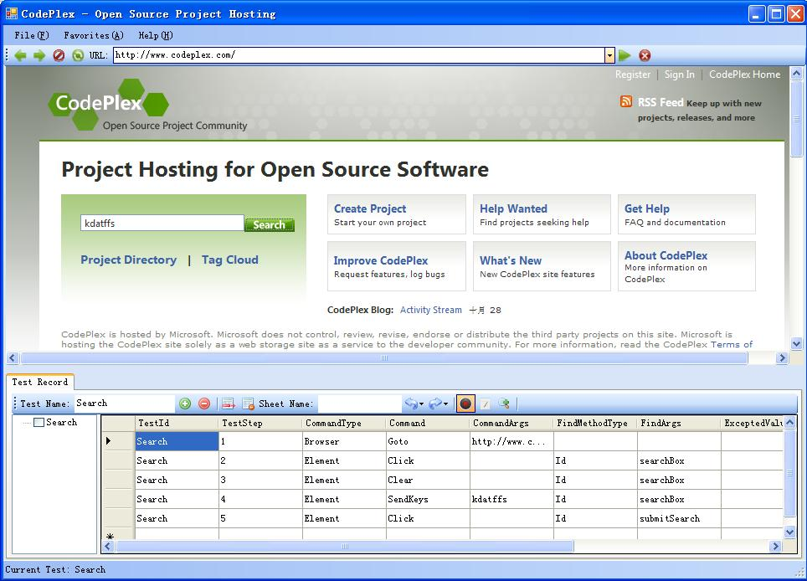

UI’s upper part is a embedded browser, you can browse web page like common browser, but in recording , opearation in browser will be recorded into “key - word” test steps, such as Back, Refresh, Click etc..
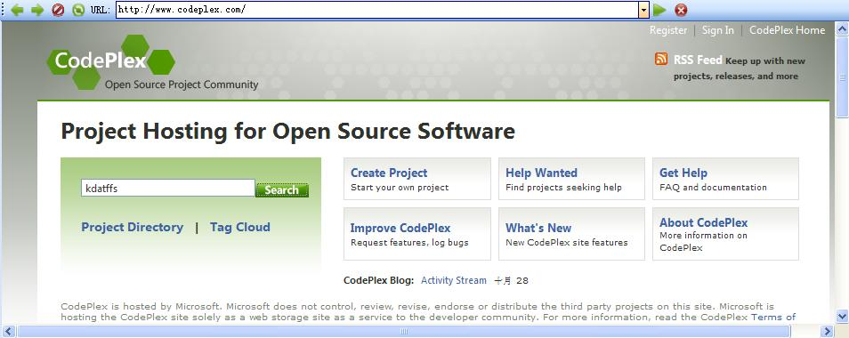

UI’s Lower Part is the main opearating area.
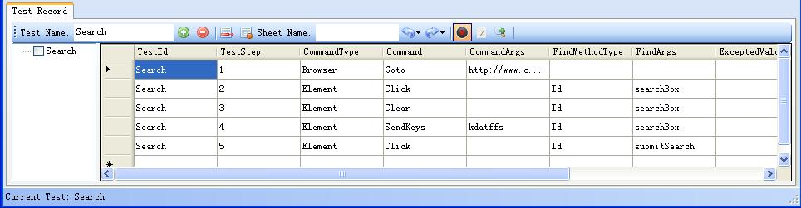

:Add a new Test , not allowed to repeat.
: Delete a Test
: Delete a Test Step
:Clear all Test Steps in a Test
: Import excel or csv file
:Export excel or csv file
: Werther begin recording. Before recording, you must select a test.

: Werther begin record comments
:Werther begin find element , add test step and vilify points

Add Test Step and vilify point Context menu.
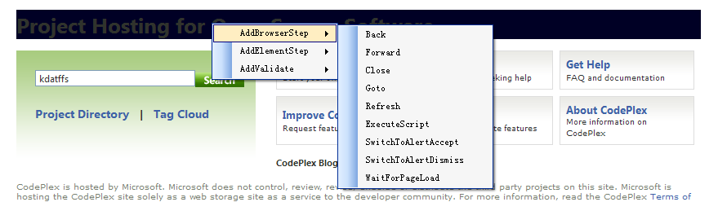

When “Find Element” button is checked , move cursor to the element which you want to add test step or vilify point ,click mouse left, Context menu appear. Choose and Click step or vilify point.

Popup Windows
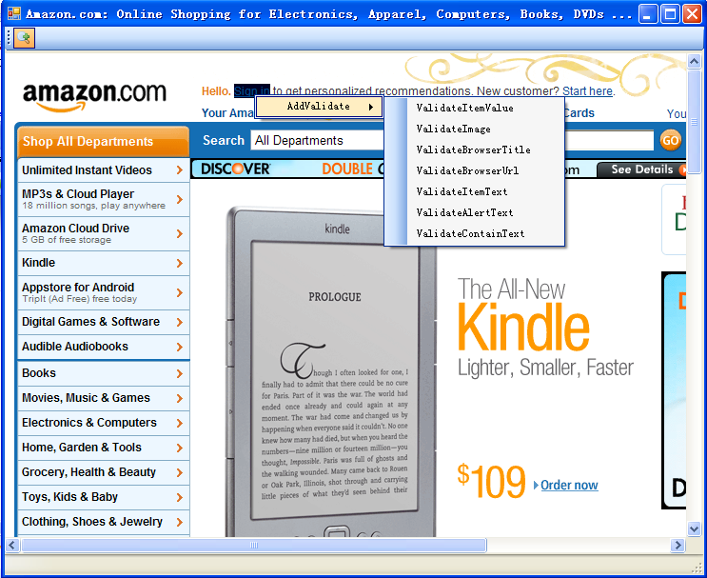

Int the popup window, you can record opearates in recroding like in main window, but only support add vilify point manual.

